Software Requirement Specifications
AgroSphere – Smart Agricultural Support s Sustainable Solution



Submitted by
- Sheraz Rafiq (F22BINFT1M01083)
- Muhammad Naveed (F22BINFT1M01112)

Submitted to
Dr. Musarat Karim

Department of Information Technology
Faculty of Computing
The Islamia University of Bahawalpur

Meeting Details
Sr No | Details | Date | Supervisor Signature
Summary
AgroSphere is a web-based agricultural support platform that helps farmers diagnose crop diseases using AI, connect with certified field officers, and access genuine pesticide products and solar irrigation services. The system includes modules for AI crop diagnosis, company product listings, solar installer services, and social media/event promotions. With real-time notifications, ratings, and a secure role-based system, AgroSphere aims to provide fast expert help, improve farmer decisions, and digitally transform agricultural support.

Table of Contents
1. Introduction 6
1.1. Purpose 6
1.2. Scope 6
1.3. Product Perspective 6
1.4. User Characteristics 6
1.5. Similar apps and systems/Literature Review 6
1.6. Proposed Technologies 6
2. Requirements 7
2.1. Function Requirements 7
2.1.1. User Registration 7
• Name: FR001 7
• Purpose: Secure registration with role-based access. 7
• User(s): All roles 7
• Input: User details, role selection 7
• Output: User account, dashboard access 7
2.1.2. Crop Disease Diagnosis 7
• Name: FR002 7
• Purpose: Farmers upload crop images for AI diagnosis 7
• User(s): Farmers, Field Officer 7
• Input: Crop image, symptoms, location 7
• Output: Diagnosis, confidence score, recommendations 7
2.1.3. Product Marketplace 7
• Name: FR003 7
• Purpose: Companies list products; farmers compare and contact 7
• User(s): Pesticide Company, Farmer 7
• Input: Product details, pricing, offers 7
• Output: Product catalog, comparison view 7
2.1.4. Solar Service Booking 7
• Name: FR004 8
• Purpose: Farmers Book solar installation/maintenance 8
• User(s): Solar Installer, Farmer 8
• Input: Service type, location, requirements 8
• Output: Service booking, quotations 8
2.1.5. Event Management 8
2.2. Non-Functional Requirements 8
5. Use Cases and Flow of Processes 8
a. Use Case 1 8
b. Use Case 2 10
c. Use Case 3 11
d. Use Case 4 13
e. Use Case 5 14
6. References 16

- Introduction
AgroSphere is a comprehensive web-based platform designed to connect farmers with agricultural service providers including pesticide companies, field officers, and solar irrigation installers through AI-powered crop diagnosis and digital service management.
  - Purpose
To provide farmers with fast, reliable agricultural solutions through AI diagnosis, expert assistance, product access, and service connections in a unified digital platform.
  - Scope
The system includes AI crop diagnosis, pesticide product marketplace, solar service booking, event management, and multi-role user management. Excludes payment processing, logistics, and mobile app in initial phase.
  - Product Perspective
A standalone web platform that can integrate with third-party services and may expand to mobile applications.
  - User Characteristics
Farmers (basic tech skills), Pesticide Companies (moderate), Field Officers (moderate), Solar Installers (basic), Admin (advanced).
  - Similar apps and systems/Literature Review
Plantix (AI diagnosis only), AgroStar (product sales only), FarmLogs (data management only). AgroSphere integrates all these features.
  - Proposed Technologies
Frontend: HTML5, CSS3, JavaScript(React.js), Tailwind CSS
Backend: PHP, Node.js, Python;
Database: MySQL, MongoDB;
AI: TensorFlow/PyTorch; AI based Integration
Cloud: AWS S3, Firebase

- Requirements
AgroSphere provides several key functionalities:
Farmers can sign up, upload crop images, receive AI diagnosis, request expert field officer review, browse pesticide products, contact companies, request solar installation, rate services, and receive notifications. Companies and installers manage products & services. Admin approves users and maintains system integrity.
  - Function Requirements
    - User Registration
- Name: FR001
- Purpose: Secure registration with role-based access.
- User(s): All roles
- Input: User details, role selection
- Output: User account, dashboard access
    - Crop Disease Diagnosis
- Name: FR002
- Purpose: Farmers upload crop images for AI diagnosis
- User(s): Farmers, Field Officer
- Input: Crop image, symptoms, location
- Output: Diagnosis, confidence score, recommendations

    - Product Marketplace
- Name: FR003
- Purpose: Companies list products; farmers compare and contact
- User(s): Pesticide Company, Farmer
- Input: Product details, pricing, offers
- Output: Product catalog, comparison view

    - Solar Service Booking
- Name: FR004
- Purpose: Farmers Book solar installation/maintenance
- User(s): Solar Installer, Farmer
- Input: Service type, location, requirements
- Output: Service booking, quotations

    - Event Management
- Name: FR005
- Purpose: Promote agricultural events and training.
- User(s): All roles
- Input: Event details, registration links
- Output: Event calendar, notifications

  - Non-Functional Requirements
- Performance: Page load < 3s, AI response < 10s
- Availability: 99.5% uptime
- Security: SSL, role-based access
- Usability: Responsive, multilingual

- Use Cases and Flow of Processes
Use cases are the formal representation of process flow defined by functional requirements. There should be system level use case which is directly influenced to project functions with their user(s) (called actor(s)) which are described in requirements chapters.
  - Use Case 1
ID | UC001
Name | Role-Based Registration
Description | User registers with specific role and permissions
Requirement(s) | FR001
Actor(s) | All roles, Admin
Precondition | New user, valid email
Postcondition | Account created with role permissions
Basic Flow | Basic Flow  - Select role  - Enter details  - Submit for approval  - Admin reviews  - Account activated

Diagram:
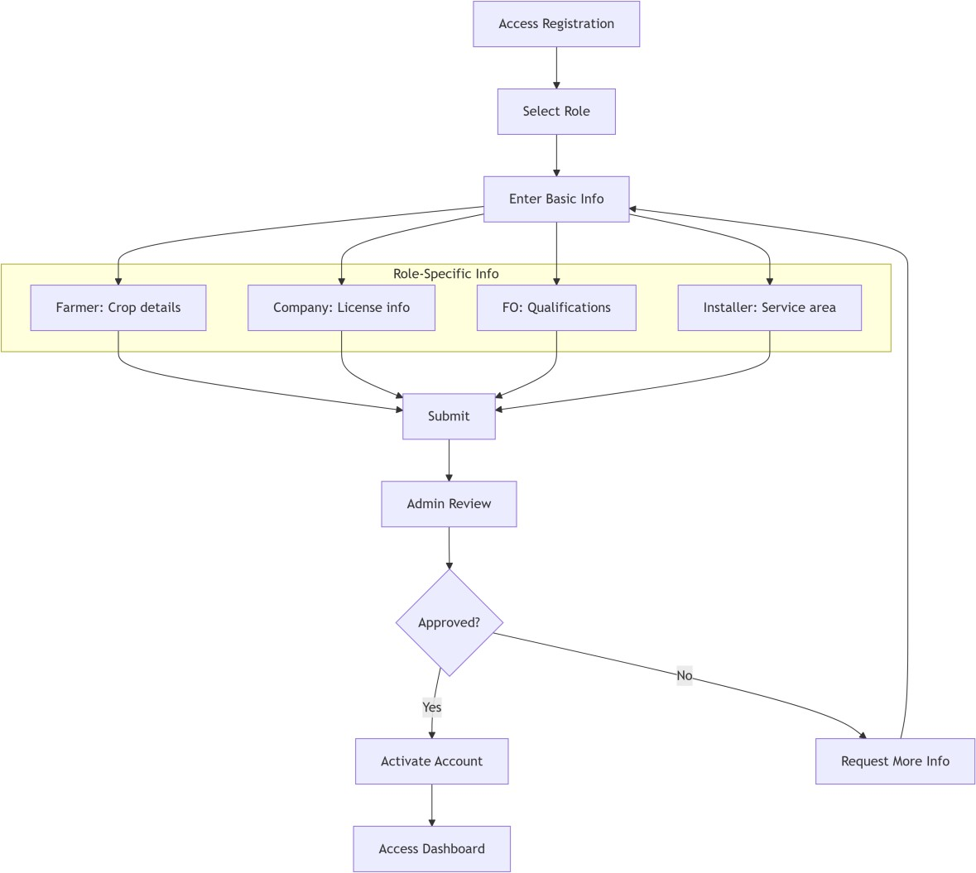

  - Use Case 2
ID | UC002
Name | AI Crop Disease Diagnosis
Description | Farmer uploads crop image for AI diagnosis with expert feedback
Requirement(s) | FR002
Actor(s) | Farmer, Field Officer
Precondition | Farmer logged in, has crop image
Postcondition | Diagnosis stored, notifications sent
Basic Flow | Basic Flow  - Upload image+symptoms  - AI analyzes  - If confidence high, show results  - Else notify FO  - FO reviews  - Notify farmer  Alternative Flow  FO directly diagnoses without AI  Exceptions  Invalid image, AI unavailable

Diagram:
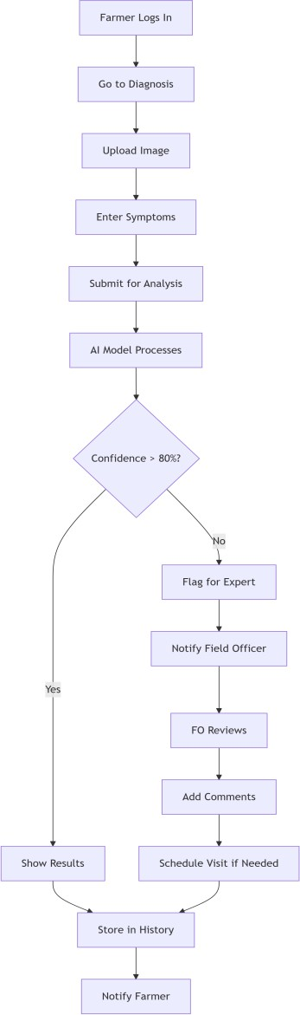

  - Use Case 3
ID | UC003
Name | Product Comparison Purchase
Description | Farmer compares pesticide products and contacts companies
Requirement(s) | FR003
Actor(s) | Farmer, Pesticide Company
Precondition | Products listed, farmer logged in
Postcondition | Contact established, potential sale
Basic Flow | Basic Flow  - Search products  - Filter and compare  - Contact company  - Negotiate  - Rate experience

Diagram:
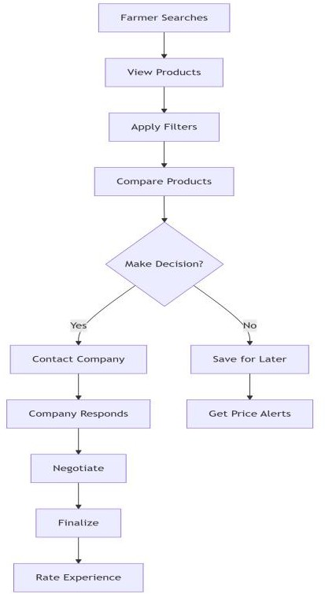

  - Use Case 4
ID | UC004
Name | Solar Service Booking
Description | Farmer requests solar irrigation services
Requirement(s) | FR004
Actor(s) | Farmer, Solar Installer
Precondition | Installers registered, farmer logged in
Postcondition | Service booked or declined
Basic Flow | Basic Flow  - Submit request  - Installer responds  - Quote negotiation  - Schedule service  - Rate service

Diagram:
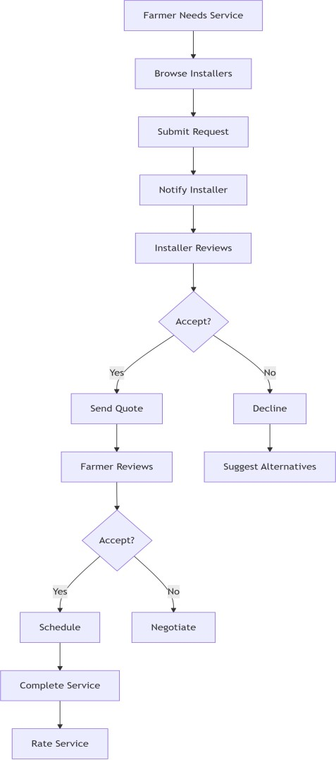

  - Use Case 5
ID | UC005
Name | Event Registration
Description | Farmers register for agricultural events
Requirement(s) | FR005
Actor(s) | Company, Farmer
Precondition | Event created, farmer logged in
Postcondition | Registration completed or saved
Basic Flow | Basic Flow  - View event  - Register interest  - Get confirmation  - Attend event  - Provide feedback

Diagram:
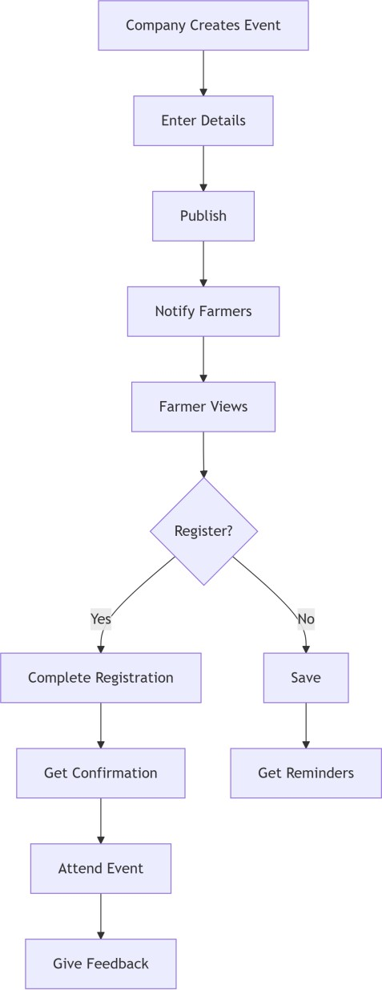

- References
- Project Proposal: "AgroSphere – Smart Agricultural Support C Sustainable Solution"
- IEEE Std 830-1998, Software Requirements Specifications
- Plantix App: https://plantix.net
- React.js Documentation: https://reactjs.org
- MongoDB Documentation: https://docs.mongodb.com

